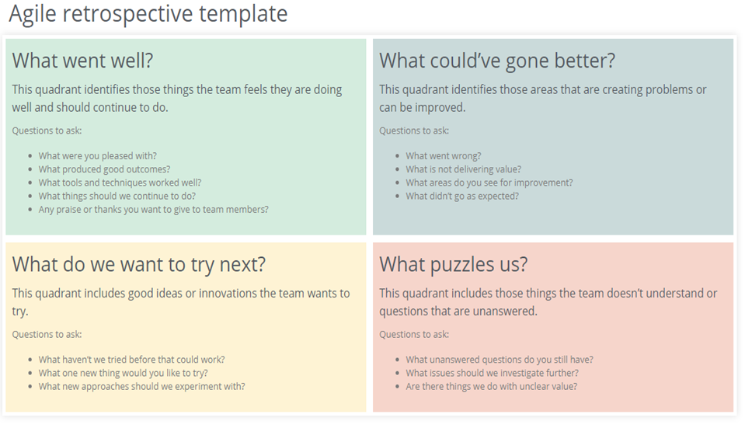

|  |  |  |
| --- | --- | --- |
| What went well   * We were pleased with our designs of the login and register pages. And also we were very excited get the servlets and dao, model, resource classes to be working in connection with front end pages. * The RESTful implementation (dao, model, resource) has proven to be very effective. For example with the help of these services we were able to retrieve our database messages from the front-end page and display them in it. * The main tools that worked well were Postman API and some online html editors. The html editors helped us while we were making front end pages. And the Postman API helped us while we were implementing the Resource class and GET methods. Postman also helped us to understand how our model class is being shown as JSON or XML file. In the end, we made our messages from the database a JSON file. And of course the eclipse itself was the tool to run the project file to see our work. The techniques that worked well were using servlet classes for Login and Logout options and using javascript for displaying searched messages. We did not want to create a servlet for the search page because using servlets would mean displaying results in a different page, and that was not a good design for us, so we decided to go with javascript. * One of the things that our Team is good at is dividing the workload among the teammates and discussing our problems by having team meetings. Each of us had our own special tasks to do until the sprint. And in the end each of us were able to contribute well to the team. And this is again what we will do through the future sprint reviews. * The guy who did the backend did a very good job, he was able to do the methods and class designs such as RESTful implementation very well. And he was also able to write the methods needed for the user stories related to sprint 1. The other Team members also did a good job with the designing of the front - end pages. Everything looked smooth, clean, and clear. |  | What could’ve gone better?   * We had trouble in search document but we were able to fix it in the end * We could have improved our front-end interface of search page so it can display the email on the right side of the same page , also we could have implemented the attachment view/download interface and could have completed the back-end of edit / grant access interface * We could have made popup button for menu to access all the pages * Completion of tasks of teammates didn't go as expected as one of our teammates wasn't responding and left. |
|  |  |  |
| What do we want to try next?   * We want to try to make an accessibility system for the documents, and try to make the service as easy to use as we can. * We want to make changes in the front end to make the web app more user friendly. For example: we want to change the look and feel of the search page, and make navigation easier (or possible at all) by creating a pop-up navigation bar. * We want to try to use libraries for the frontend to make our lives easier. * Lastly, we want to improve on the security of the app by using the knowledge we gathered in the lectures. |  | What puzzles us?   * It was mentioned that we should find documents without having to go through email which confused us as we did not understand what this meant. * Certain programming aspects still confuse us such as we sometimes have technical issues with how servlets work which needs a deeper investigation. * There are a few things that we start without the clearest aim or goal in mind, however this gives us flexibility at the cost of a little bit of efficiency as we program new things as we need them. |